CHAPTER 5: Ecosystems — flow of energy and matter
Worksheet 5.1

Food webs
Science Quest 9: pages 178–82
Answers
1. Examine the two graphics below and answer the questions that follow.
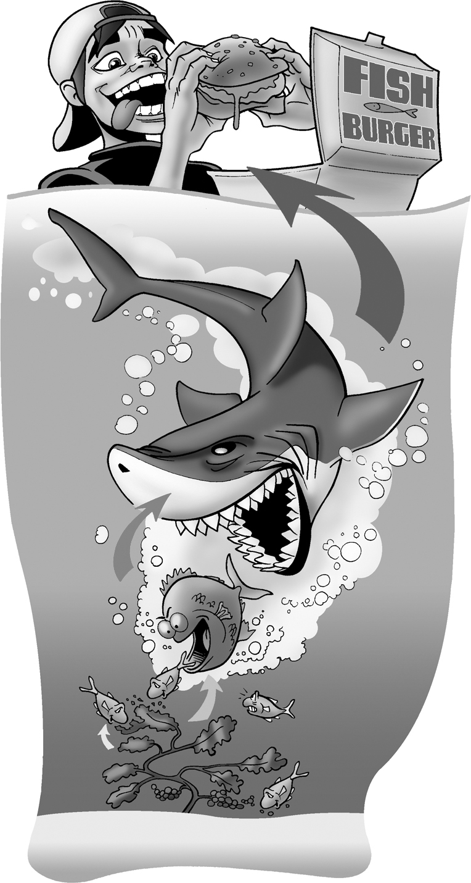 | 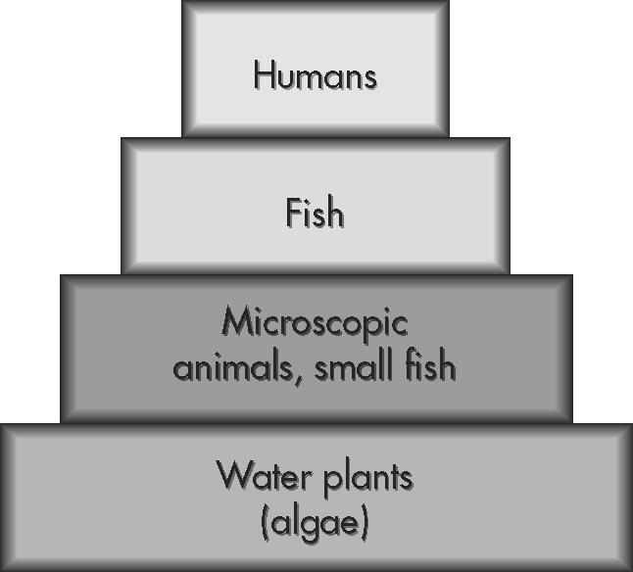
(a) Identify the producers in the food chain.
Water plants (algae)
Third order consumer
(b) In this food chain what type of consumer are the humans?
(c) Explain why the food chain is represented as a pyramid.
The food chain is an energy pyramid. The producers’ total mass represents the greatest amount of energy. As the producers are eaten by the first order consumers, however, some energy is lost in the form of heat. As one moves up the pyramid the amount of energy available decreases.

(d) What is the ultimate source of energy for this food chain?
The sun (solar energy)

CHAPTER 5: Ecosystems — flow of energy and matter
Worksheet 5.1

Page 2

2. Examine the food web below and answer the questions that follow.
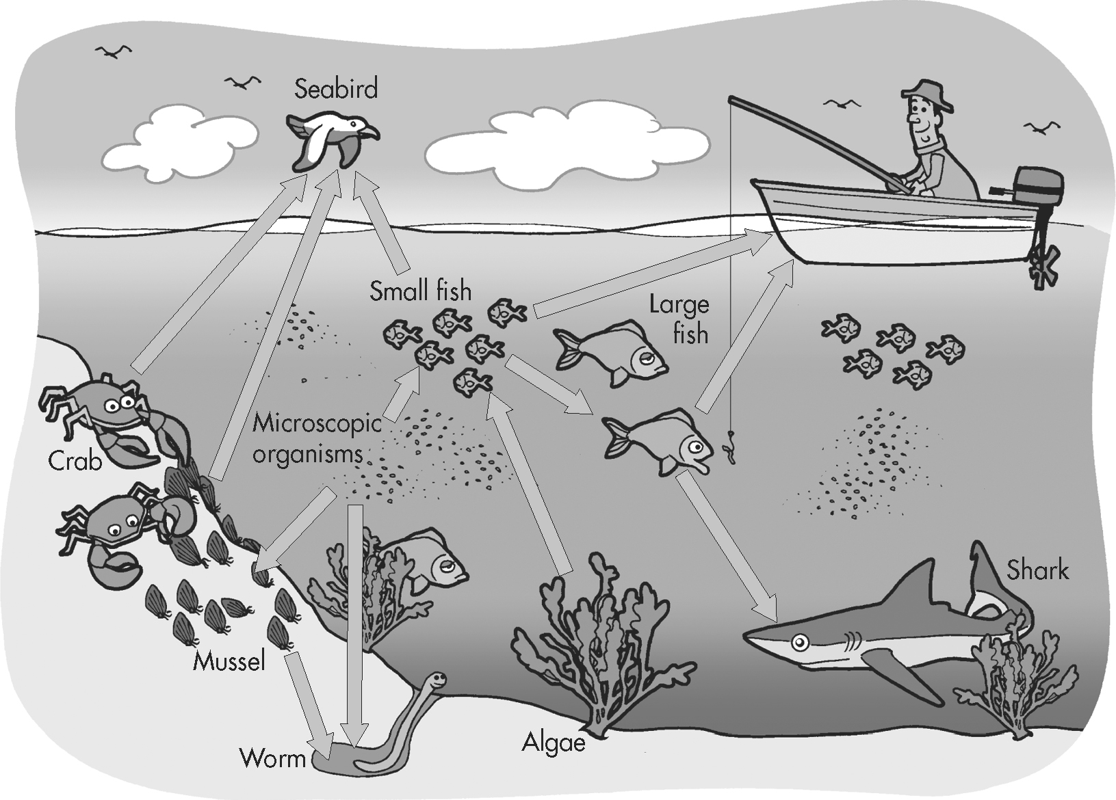
(a) What type of living things could make up the ‘microscopic organisms’?
Microscopic producers, microscopic consumers and decomposers

(b) Write a food chain based on this food web that includes a third order consumer.
Algae → small fish → large fish → shark (or human)

(c) If a disease kills all the algae in this area what effect will this have on the food web?
The population of small fish will decline since algae represent one of the food sources of the small fish. This in turn will reduce the population of large fish and sharks that depend on these smaller fish. Sea bird populations in that area may also decrease.

